Configure SystemInit Fuction

#if (__FPU_PRESENT == 1) && (__FPU_USED == 1)

SCB->CPACR |= ((3UL << 10*2)|(3UL << 11*2)); /* set CP10 and CP11 Full Access */

#endif

/* Reset the RCC clock configuration to the default reset state ------------*/

/* Set HSION bit */

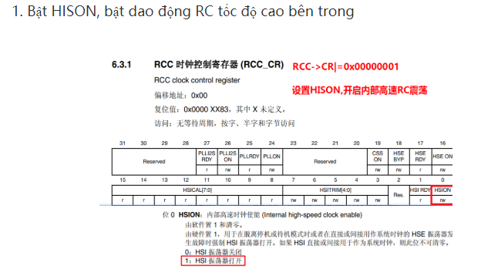

RCC->CR |= (uint32_t)0x00000001;

/* Reset CFGR register */

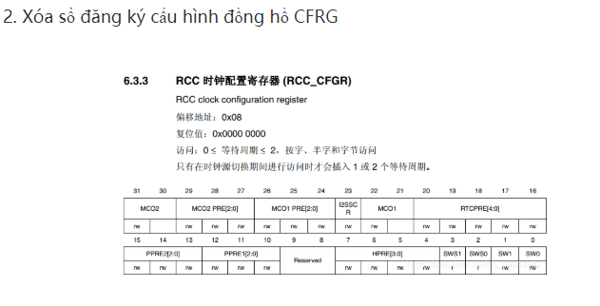

RCC->CFGR = 0x00000000;

/* Reset HSEON, CSSON and PLLON bits */

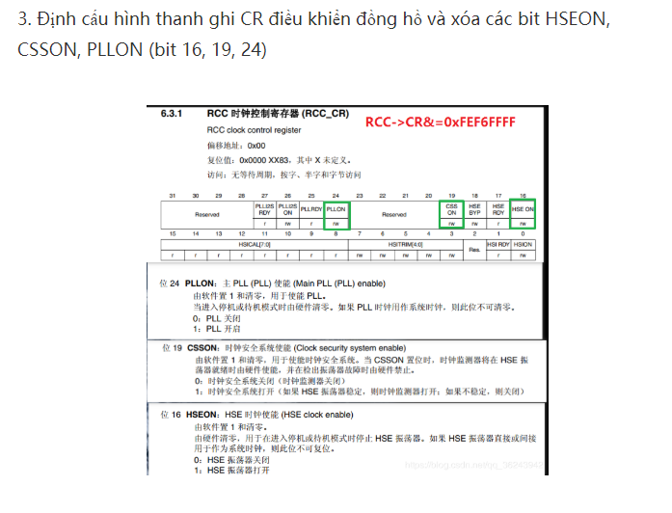

RCC->CR &= (uint32_t)0xFEF6FFFF;

/* Reset PLLCFGR register */

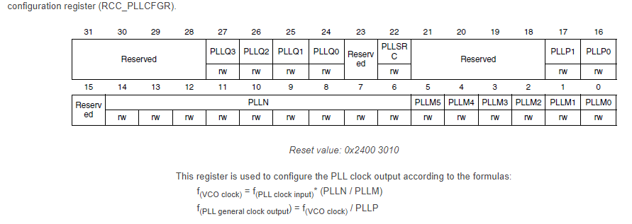

RCC->PLLCFGR = 0x24003010;

/* Reset HSEBYP bit */

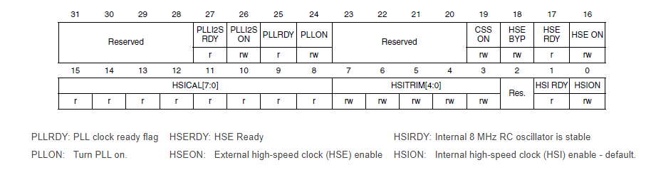

RCC->CR &= (uint32_t)0xFFFBFFFF;

/* Disable all interrupts */

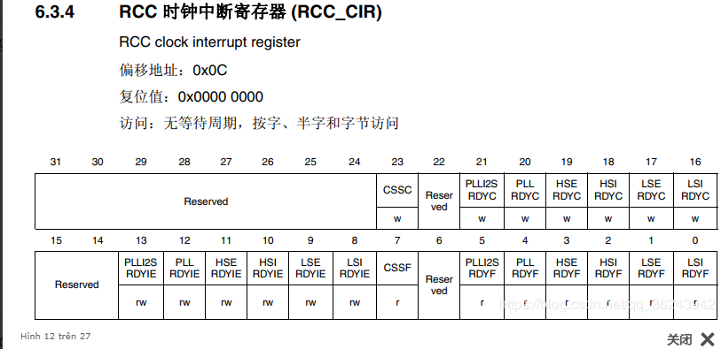

RCC->CIR = 0x00000000;

#ifdef DATA_IN_ExtSRAM

SystemInit_ExtMemCtl();

#endif /* DATA_IN_ExtSRAM */

SetSysClock();

Configure SetSysClock Fuction

/* Enable HSE */

RCC->CR |= ((uint32_t)RCC_CR_HSEON);

/* Wait till HSE is ready and if Time out is reached exit */

do

{

HSEStatus = RCC->CR & RCC_CR_HSERDY;

StartUpCounter++;

} while((HSEStatus == 0) && (StartUpCounter != HSE_STARTUP_TIMEOUT));

if ((RCC->CR & RCC_CR_HSERDY) != RESET)

{

HSEStatus = (uint32_t)0x01;

}

else

{

HSEStatus = (uint32_t)0x00;

}

if (HSEStatus == (uint32_t)0x01)

{

/* Select regulator voltage output Scale 1 mode, System frequency up to 168 MHz */

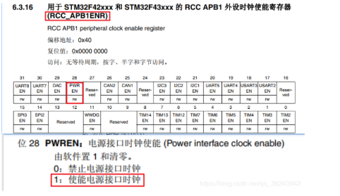

RCC->APB1ENR |=1<<28; ;

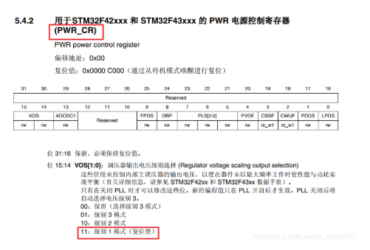

PWR->CR|=3<<14;

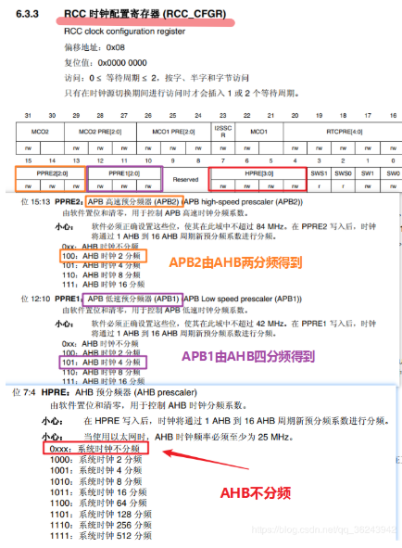

RCC-> CFGR | = (0 << 4) | (5 << 10) | (4 << 13);

// HCLK không bị chia; APB1 chia cho 4; APB2 chia cho 2.

/* HCLK = SYSCLK / 1*/

RCC->CFGR |= RCC_CFGR_HPRE_DIV1;

/* PCLK2 = HCLK / 2*/

RCC->CFGR |= RCC_CFGR_PPRE2_DIV2;

/* PCLK1 = HCLK / 4*/

RCC->CFGR |= RCC_CFGR_PPRE1_DIV4;



RCC-> CR & = ~ (1 << 24); // Tắt PLL chính

/* Configure the main PLL */

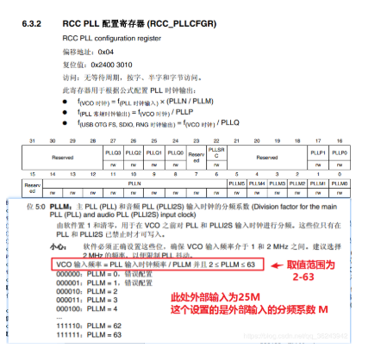

RCC->PLLCFGR = PLL_M | (PLL_N << 6) | (((PLL_P >> 1) -1) << 16) | (1 << 22)| (PLL_Q << 24);

(1 << 22), chọn nguồn đồng hồ của PLL chính là đồng hồ dao động bên ngoài HSE ,

/* Enable the main PLL */

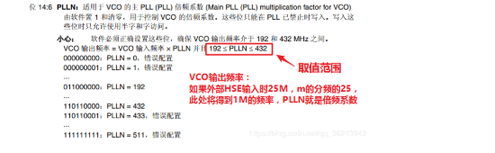

RCC->CR |= RCC_CR_PLLON;

/* Wait till the main PLL is ready */

while((RCC->CR & RCC_CR_PLLRDY) == 0)

{

}

/* Configure Flash prefetch, Instruction cache, Data cache and wait state */

FLASH->ACR = FLASH_ACR_ICEN |FLASH_ACR_DCEN |FLASH_ACR_LATENCY_5WS;

FLASH-> ACR | = 1 << 8; // Cho phép tìm nạp trước lệnh.

FLASH-> ACR | = 1 << 9; // Kích hoạt bộ đệm lệnh.

FLASH-> ACR | = 1 << 10; // Bật bộ nhớ cache dữ liệu.

FLASH-> ACR | = 5 << 0; // 5 chu kỳ chờ CPU.

/* Select the main PLL as system clock source */

RCC->CFGR &= (uint32_t)((uint32_t)~(RCC_CFGR_SW));

RCC->CFGR |= RCC_CFGR_SW_PLL;

/* Wait till the main PLL is used as system clock source */

while ((RCC->CFGR & (uint32_t)RCC_CFGR_SWS ) != RCC_CFGR_SWS_PLL);

{

}

else

{

//*****//

}